Things That Need to Be Improved, and Questions
1. Genset>Engine Runtime & Starts
- Remove the two decimal places; show whole numbers only.
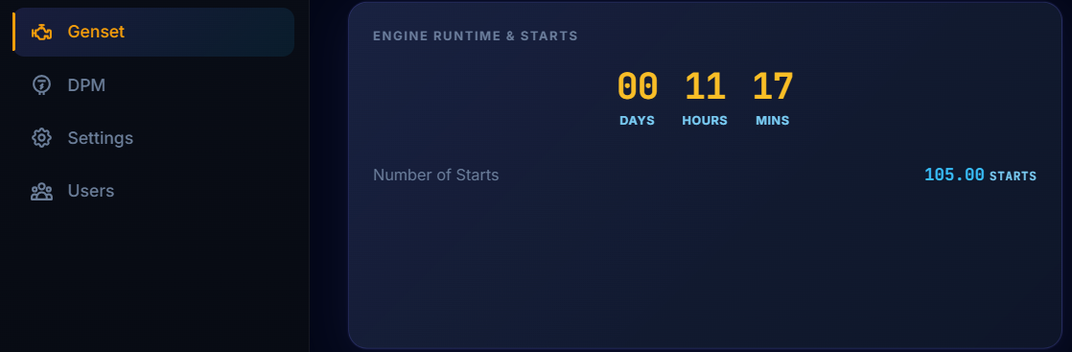
2. Is the current data dummy data?
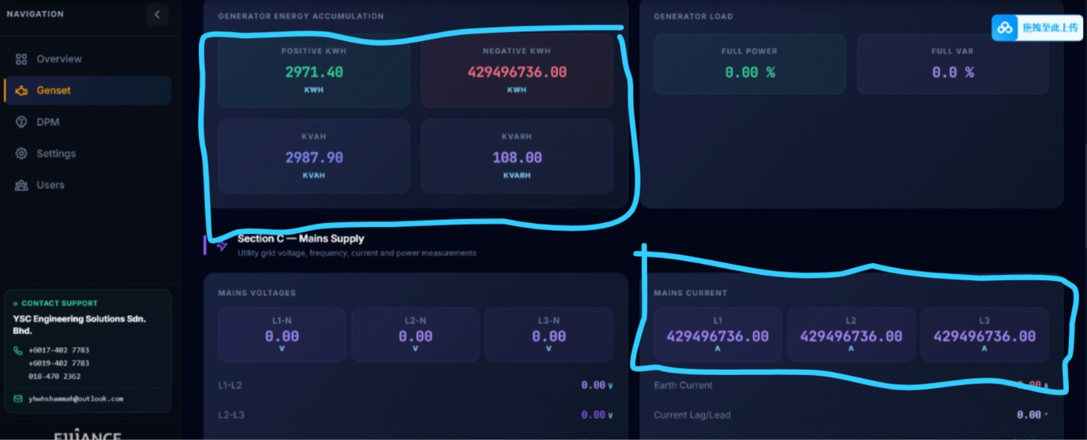
3. Add SMTP configuration and send SMS/email notifications.
4. DPM > Change the title to AMF Board Outgoing DPM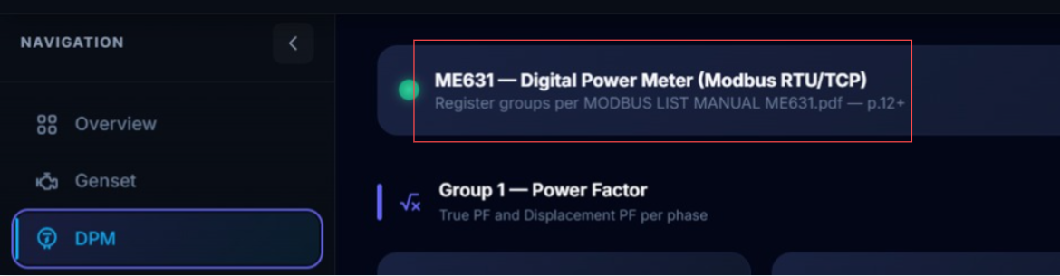

5. Can we get the Import & Export details from the current DPM?
- The customer asked to remove Import and keep the Export part only, and to remove the word "Export" and keep only Phase 1, 2, 3.
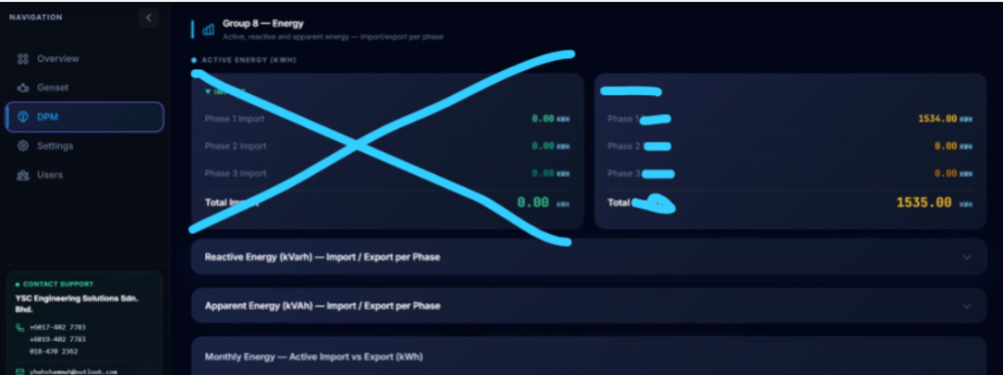
6. For the trend graph, is there a feature to export the data to Excel (CSV/other formats)? One year of data.
What is our current data retention period? Is it one year, FIFO?
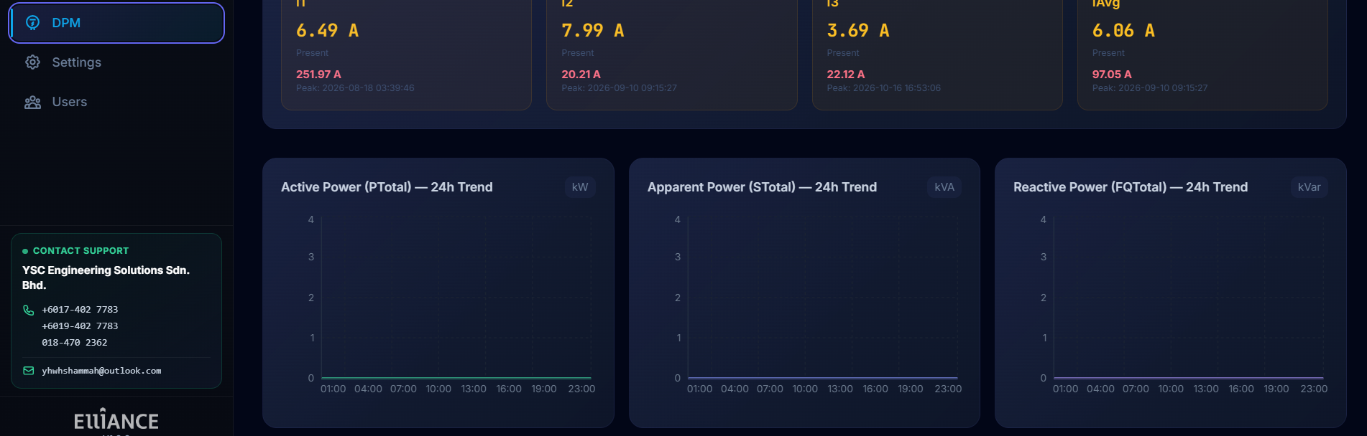

7. Is the alarm register something we can get from the genset device? Does the customer need to choose only the alarms they want to be alerted on?

